New York Times Online
July 26, 2018
https://www.nytimes.com/2018/07/26/travel/family-reunion-tips.html?rref=collection%2Fsectioncollection%2Ftravel

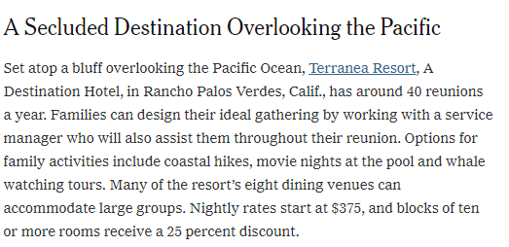
New York Times Print

July 29, 2018

http://images.burrellesluce.com/image/U2FsdGVkX19jD5FOvoEIGeFPXcio_ChV34lhNKUZLIcMnIZ46lIlYg

