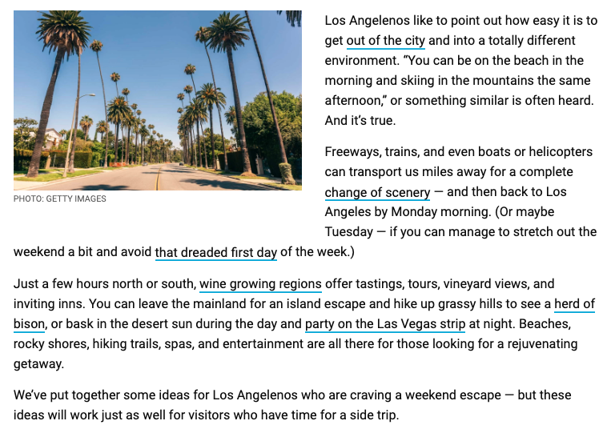
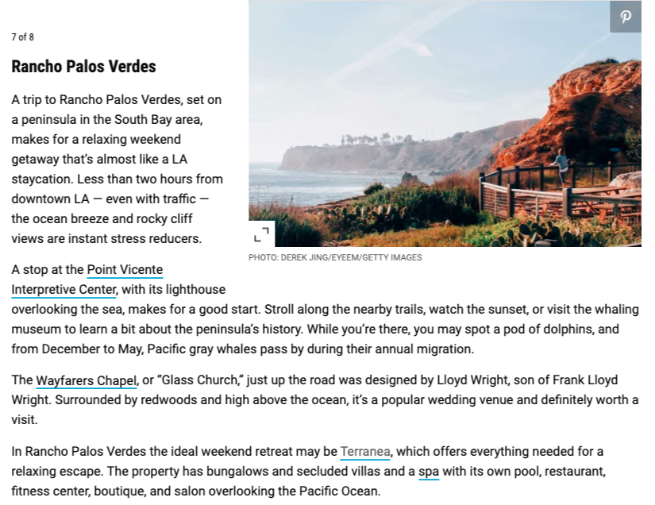

https://www.travelandleisure.com/weekend-getaways/los-angeles/weekend-getaway-trip-ideas-from-los-angeles?slide=790882#790882

